PRECRIME

Bachelor of Engineering in Information Technology
by
Nitesh Mistry
Imran Memon
Asim Shaikh
Under the Guidance of
Prof. Gayatri Dantal



SHREE L. R. TIWARI COLLEGE OF ENGINEERING, MIRA ROAD
(Approved by AICTE, Govt. of Maharashtra & Affiliated to University of Mumbai)

DEPARTMENT OF INFORMATION TECHNOLOGY
2013-14

PROJECT REPORT
ON
PRECRIME

Submitted in partial fulfillment of the requirements for the degree of
BACHELOR OF ENGINEERING
by
Nitesh Mistry
Imran Memon
Asim Shaikh
Under the Guidance of
Prof. Gayatri Dantal

SHREE L. R. TIWARI COLLEGE OF ENGINEERING, MIRA ROAD
(Approved by AICTE, Govt. of Maharashtra & Affiliated to University of Mumbai)
DEPARTMENT OF INFORMATION TECHNOLOGY
2013-14
SHREE L. R. TIWARI COLLEGE OF ENGINEERING,MIRA ROAD
(Approved by AICTE, Govt. of Maharashtra & Affiliated to University of Mumbai)
Department of Information Technology
UNIVERSITY OF MUMBAI
CERTIFICATE
This is to certify that the project titled “PreCrime” has been partially completed under our supervision and guidance by the following students:
Nitesh Mistry
Imran Memon
Asim Shaikh
In the partial fulfillment of degree of Bachelor of Engineering in Information and Technology branch as prescribed by the University of Mumbai during the academic year 2013-2014. The said work has been assessed and is found to be satisfactory.

Signature of the Internal Examiner Signature of the External examiner
Name: _____________ Name: ______________
Date: _____________ Date: _______________
Signature of the Coordinator Signature of the HOD
Name: _____________ Name: ______________
Date: _____________ Date: _______________

Dr. S. Ram Reddy
Principal

EXISTING SYSTEMS
- RAPID INFORMATION OVERLAY TECHNOLOGY (RIOT)
Raytheon, a major American defense contractor has secretly developed software capable of tracking people's movements and predicting future behavior by mining data from social networking websites.
Using Riot it is possible to gain an entire snapshot of a person's life – their friends, the places they visit charted on a map – in little more than a few clicks of a button.
Riot pulls out this information, showing not only the photographs posted onto social networks by individuals, but also the location at which the photographs were taken.
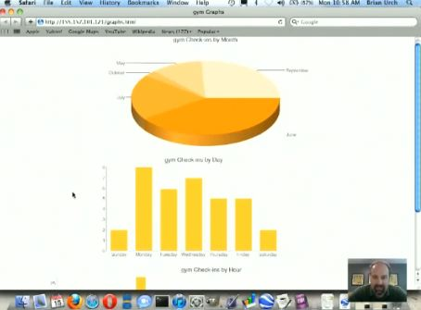
A look into the specifics of user’s daily schedule based on check-in trends.
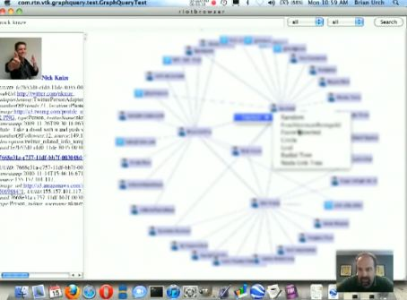
A web of user’s connections with other people. Some phone numbers were included too.

- CLEAR
Thomson Reuters has created “CLEAR®”, an investigative suite that can be used for pre-crime detecting. The company recently released a research white paper done by its Fraud Prevention and Investigation unit. The white paper explores the growth, use, and legal and privacy challenges of pre-crime detecting, and examines the use of such capabilities in the forecasting of criminal activity.
CLEAR has both public and proprietary records, arrest and incarceration records, photo lineups, work affiliations data, and other resources, and the methodology of its “Web Analytics” to search and categorize social media, blogs, news sites and watch lists. Such public and proprietary records are then integrated into the user’s systems or searched via online platforms. Such integration can be done with large-volume batch capabilities and batch alerting functionality to identify and intercept individuals and/or organizations likely to participate in criminal activity.

- PREDPOL
A map of a city is marked up with small red squares, each indicating a 500-by-500-foot zone where crimes are likely to take place next. A heat-map mode shows even more precisely where cars may be stolen, houses robbed, people mugged.
The program is called PredPol, and it calculates its forecasts based on times and locations of previous crimes, combined with sociological information about criminal behavior and patterns.

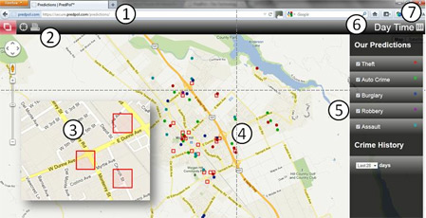

- TWEETSTRAP
The goal of this project is to “Tweetstrap”/bootstrap a marketer to find the twitter mini-celebrities (beyond the “usual suspects”) to target to help market his test tweet. The predictions are done based on the influence source of the tweet i.e. popularity of the source tweeter, the length of the cascade chains that the tweet generated and also analysis of the content of the tweets (topics from the words or links it contains).
The aim is to develop a regression model (support vector based) that will predict the popularity of a tweet (by giving retweet counts), factoring in various attributes of tweets from a training set for each celebrity user.
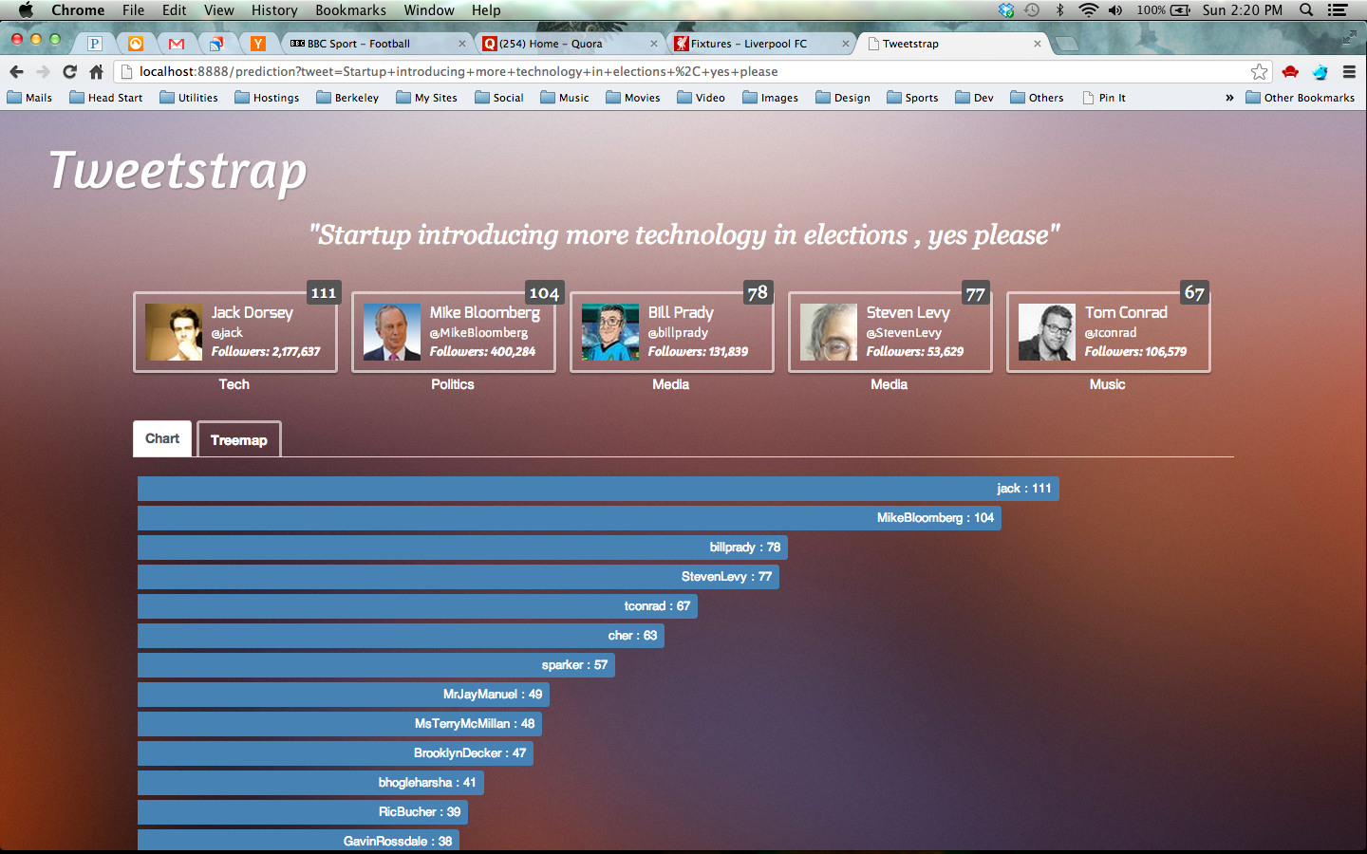
Histogram visualization
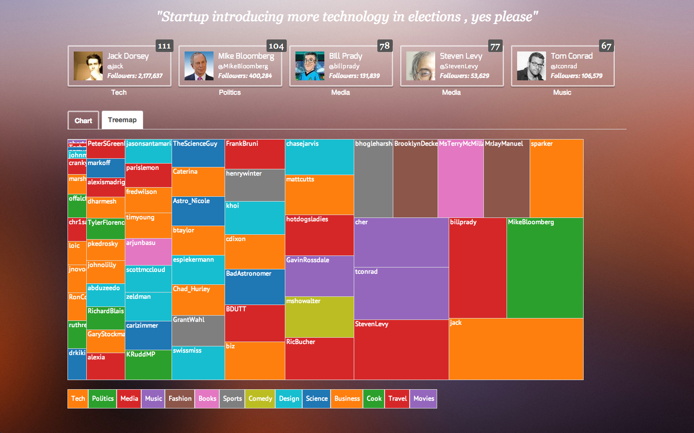
Treemap Visualization

